**INTRODUCTION**

***Radiation Knowledge*** is a non-profit quality improvement initiative, which shares the best practical knowledge among professionals working in the field of radiation therapy.

This document is about the 2018 **Left Chest Wall – 3D-CRT** Competition

**LEARNING OBJECTIVES**

* To understand the capabilities of different TPSs, what can be achieved by planners, and balance between complexity and deliverability
* To share the best dosimetric plans and compare the ease and practicality of delivery

**ABOUT THE CASE**

**Case** :Left Chest Wall

**Dose Prescription** : 50 Gy in 25 fractions (2 Gy/fr)

**Contouring Protocol**  : ESTRO (Dr. Noha (If this needs modification, or remove))

**Modalities** : 3D-CRT and TomoDirect

**TWELVE DOSIMETRIC OBJECTIVE - Total Score of 100)**

1. Target coverage and : 50 Points
2. Organs At Risk (OARs) and normal tissue sparing: 50 Points

**PLAN COMPETITION PACKAGES**

**DFG**

**PACKAGE (1) – May 15th, 2018**

* Package (1) Document: For the Left Chest Wall Case
* DICOM Sets: CT Image and Structure Sets

**PACKAGE (2) - May 21st, 2018**

* Package (2) Document: Q&A and updates
* PyPlanScoring software for the Left Chest Wall Case
* VC++ 2017 Redist.: Installed **in case of** “Entry Point” Error when using PyPlanScoring

**START & END DATES**

3

**Start Date:** **May 15th, 2018**  **End Date:** **May 30th, 2018**

**GLOBAL RADIOTHERAPY DATACENTER**

* **Radiation Knowledge** team has started establishing ***a Radiotherapy Datacenter***, which will be initiated **right after the competition ends**. This datacenter will be an online platform for planners in the world to exchange their knowledge related to **All Radiotherapy Stages**: Simulation, Contouring, Planning, and treatment delivery.
* The **datacenter** will collect data from planners through ***Online Clinical Surveys*,** which will establish a ***global radiotherapy data bank*** that will help in exchanging advanced clinical and practical knowledge among **Radiation Oncologists**, **Physicists**, Dosimetrists, and **Therapists**.

**LEFT CHEST WALL/BREAST SURVEY**

**The Left Chest Wall/Breast Treatment Survey:**

* The **Left Chest Wall 3D-CRT** activity is the first of its kind in the world, it aims at exchanging the world’s experience in the treatment of left chest wall.
* After the competition ends, planners will be requested to fill a **Left Chest Wall/Breast Survey,** which aims at exchangingthe processes implemented in their clinics

**COMPETITION GUIDELINES - CONTOURING**

* The case was contoured based on **ESTRO recommendations**
* PyPlanScoring scores plans based on the structure set in **Package (1)**, NOT planners’ set
* Adding uniform **0.5-1.5 cm bolus** is allowed
* Adding **irregular bolus** is allowed, which can be **3D Printed** or generated somehow:

**The treatment setup SHOULD be reproduced on the treatment unit from day-to-day**

**Description of Targets: (Dr. Noha)**

1. **PTVN_AX_L:**
2. **PTVN_SCL_L:**
3. **PTVN_IMN_L:**
4. **LT_CW_PTV_EVAL:**

**PLANNING GUIDELINES**

**TYPE OF TECHNIQUES/PLANS FOR PLANNING**

It is a

* Only **Forward planning** technique is allowed, **NOT** inverse planning
* TECHNIQUE 1: **Photon Only** Plans (mixed energies)
* TECHNIQUE 2: **Photon-Electron** **(P/-e)** combination (mixed energies)
* Planners can choose ***one technique or more***
* Conventional techniques, i.e. half-beam blocked with tangent beams are allowed
* Other techniques, i.e. **Electron Beam Only** plans, can also be used
* ***Be creative, think of new easy to deliver techniques with improved outcomes***

**TYPES OF BEAM ATTENUATORS**

The following beam attenuators are allowed:

* Multi-Leaf Collimators (MLC)
* Cerrobend Blocks
* Wedges
* Electron CutOuts
* All forward planning options provided by all TPS

**FIELD GEOMETRY & ARRANGEMENTS**

**FOR PHOTON PLANS**

* **ONLY ONE ISOCENTER** is allowed.
* Max of **FOUR** gantry angles are allowed per plan:

Example: Using **6X** & **15X** beams **from same angle** counted as **ONE** gantry angle

* Max of **SIX Primary fields** are allowed per plan:

**Examples:** Sub-field segments inside a primary field are **NOT** counted as a field

**FOR (P/-e) PLANS**

* For photon plans :All the above Photon Plans’ requirements apply to P/-e plans
* For –e plans (Per Plan Requirements):

1. Max of **FOUR** gantry angles, **SIX** beams, and **THREE** energies are allowed
2. Max of **THREE** different SSD and **THREE** CutOuts are allowed

**For –e plans (Per Plan Requirements):**

1. Max of **FOUR** gantry angles, **SIX** beams, and **THREE** energies are allowed
2. Max of **THREE** different SSD and **THREE** CutOuts are allowed

**DOSE FRACTIONATION – EXAMPLE**

1. **Photon Only Plans: (Total of 50.0 Gy in 25 fractions)**

Plan 1 - With Bolus: 24 Gy in 12 fractions

Plan 2 - Without Bolus: 26 Gy in 13 fractions

Plan 3 – SCLAV: 50.0 Gy in 25 fractions

1. **P/-e Plans: (Not Boost Plan)**

Plan 1 – Plan 3: Same as “**Photon Only**” above

Plan 4 – Electron: 50.0 Gy in 25 fractions

**Tomotherapy – TomoDirect**

**TomoDirect 3D-CRT option is allowed to be used, not IMRT option**

**INSTRUCTIONS – GETTING STARTED**

After you receive a notification from RK that the package is ready, follow these steps:

**Pre-Planning Stage:**

1. Login to your account in radiation knowledge: [www.radiationknowledge.org](http://www.radiationknowledge.org)
2. **Dashboard -> Competition Brief ->**  **3D-CRT Left Chest Wall -> Download**
3. After downloading **Package (1), Unzip** the package and import the DICOM sets into your TPS
4. **Package (2)** will be ready to download on **May 18th, 2018**
5. Read the dosimetric criteria for the competition
6. Start planning

**Plan Evaluation Stage:**

1. Steps of evaluating the plan using PyPlanScoring will be provided in **Package (2)** document
2. Three files are required to evaluate your plans: RS (Structure), RD (Dose) and RP (Plans)
3. Regarding the RD dose files:

PyPlanScoring allows planners to import more than one dose file and sum them all together, **BUT UNDER ONE CONDITION**:

The dose calculation grid **for All Plans** submitted (photon and electron (if any)) should use the **same dose calculation** grid size (less than 3mm).

**Example:**

If Plan1 (With Bolus) used 2.5 mm size, then all other plans **should** use 2.5 mm grid as well.

**Plan Submission Stage:**

* When you reach your best plan and want to submit it as a final plan:

Compress the final plan folder, go to [www.radiationknowledge.org](http://www.radiationknowledge.org), follow these steps

**Dashboard -> Submit Plan -> 3D-CRT Left Chest Wall**

Kindly: ***Follow the naming convention recommended on the Plan Submission page***

**DOSIMETRIC CRITERIA – LEFT CHEST WALL Case**

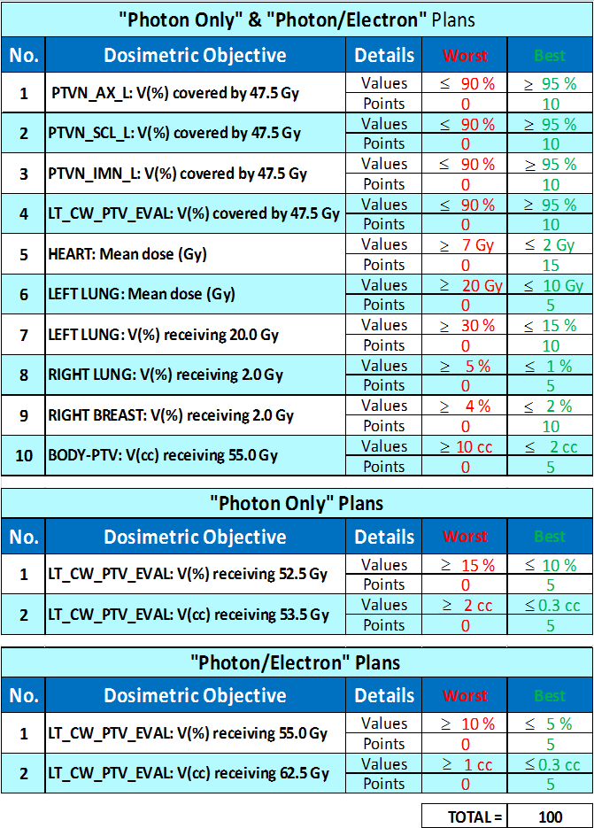

**PLAN EVALUATION**

* Aside from the PyPlanScoring plan scoring, a subjective clinical review will be introduced
* The best cases will be reviewed by world leading radiation oncologists, this will also be considered in the final plan score and top planners ranking.

***So, be creative ... Keep the clinical aspects (Simplicity/deliverability) in mind***

**PLAN SUBMISSIONS & CONFIDENTIALITY**

* The competition is a pure educational activity, the goal behind it is to share the best planning strategies among planners worldwide
* We encourage all participants to submit their plans ***regardless of their scores***
* To ensure confidentiality, the **Institution Name** is made optional in the submission form

**PRIZES & TOP PLANNERS’ LIST – BE AMONG THE TOP**

* More than 10 000 USD allocated for the Radiation Knowledge 2018 competitions as prizes for top planners, these prizes are provided by the **Saudi Oncology Society (SOS)**
* None of the offered prizes are paid by vendors

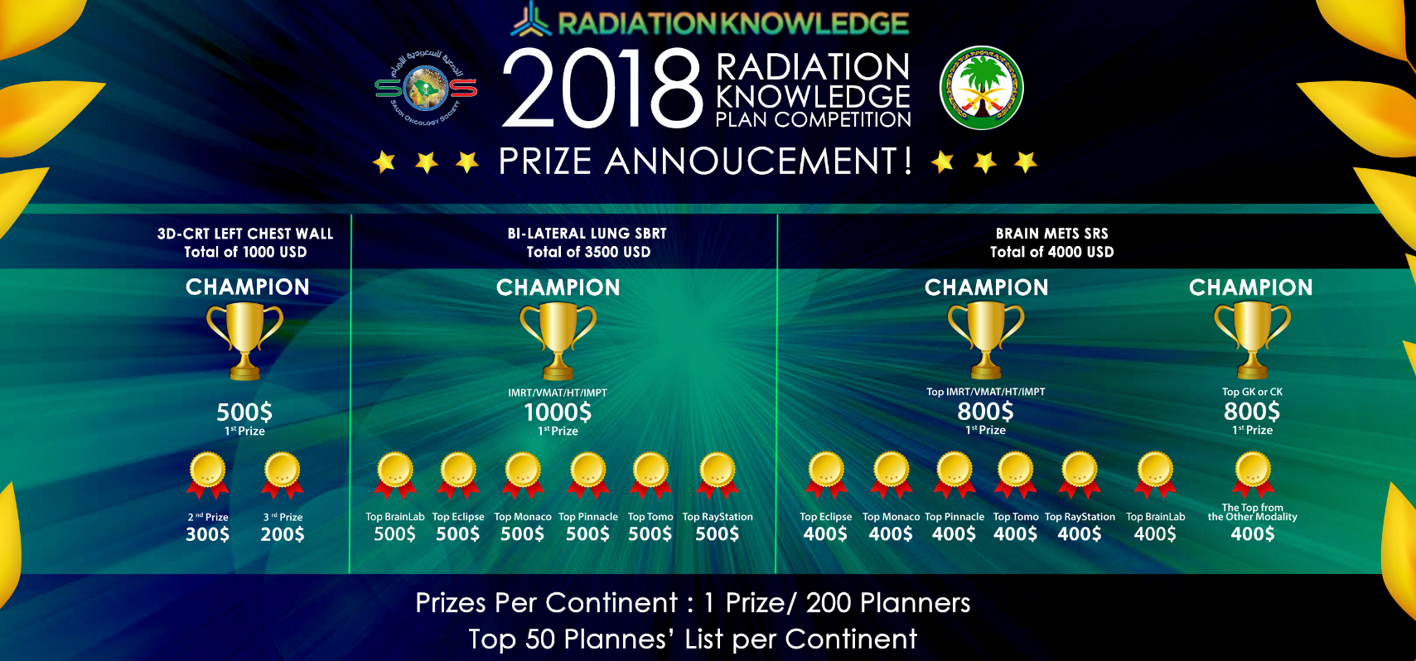

**Contact Us**

|  |  |
| --- | --- |
| **EMAIL ADDRESS** | [ahmad@radiationknowledge.org](mailto:ahmad@radiationknowledge.org)  OR  anobah@kfshrc.edu.sa |
| **RT Plan Competition WhatsApp Group**  **Follow us on Twitter**  **Facebook Page** | Group Admin No. +966-53-127-1245  @RadiationKnow  Radiation Knowledge |

**We wish you best of luck**

**Kindly share** [**www.radiationknowledge.org**](http://www.radiationknowledge.org)